**Module 05**

**IE 5329 – Project Management, Fall Semester 2024**

Dr. Jennifer Cross

____________________________________________________

Internet of Things Drones Integration

**Team 3**

Mohammed Noor Alabbasi, Project Lead

Arsalan Habib

Emila Lopez

Victoria Velasquez

Arun Chandana

Dhana Gandham

Loic Wega

**Introduction and Updates:**

**Roles and Responsibilities of Team Members**

**Organizational Structure Selection**

Organization structure is how a project team is set up to help manage and carry out the project. It defines the roles, responsibilities, and hierarchy within the team, making sure everyone knows who is in charge and how communication and decisions should flow. There are different types of structures for an organization like classical(functional) organization, project(product) organization and matrix organization. These 3 types of organizations have their own merits and demerits

**Classical or functional organization**

Organizing people by their skills means creating both permanent and temporary teams. Permanent teams like departments, group people with similar skills. Temporary teams, like project groups, bring together people with different skills to work on a specific project. This helps mix expertise with flexibility for different tasks. In this type of structure, we have different types of sections working under a general manager. This type of structure is simple to understand. We have a simple treelike structure.

**Project or product organization**

Organizing people based on major product lines, with each product line having its own structure like a functional setup. Some functional departments, such as accounting, continue to support all product lines. Permanent teams are created around specific product lines or programs, bringing together people from different disciplines. For short-term tasks, temporary project teams are formed, either with people from similar or different areas, to focus on specific objectives. This approach helps align resources with the needs of each product while maintaining flexibility. Product organization is like breaking a big project into smaller, separate projects, each focused on a specific product. This helps improve efficiency by giving each smaller project more attention and resources.

**Matrix organization**

Organization created on the basis of advantages of functional and product organizations. Permanent structures are used to group people from the same or different disciplines, creating teams that stay in place over time. Temporary structures, like short-term project teams, are formed to bring together people with various skills for specific tasks or projects. These flexible setups help ensure the right expertise is available when needed, whether for ongoing work or short-term goals.in simple terms it is like creating a matrix with project requirements and functional responsibilities on x and y axis.it is more complicated than the other two.

After evaluating the three organizational structures—functional, matrix, and product-based—and considering the merits and demerits of each and from the similar successful running companies like DJI, our team took the decision to consider the **Classical or functional organization**

We have chosen the classical or functional organization structure because as a small company in its early stages, it offers several key benefits. This structure allows us to clearly **define roles and responsibilities**, making it easier to allocate tasks based on technical expertise. Employees are grouped according to their skills, which improves focus and specialization. This also **simplifies resource management**, as we can allocate personnel efficiently across different functions, minimizing redundancy. The functional structure is cost-effective, ensuring that resources are used optimally, which is crucial for a growing company. It also fosters **clear communication between employees and management**, making it easier to share technical knowledge and maintain alignment across departments. This type of organization is the **least costly to operate**.

In addition, the functional structure enhances specialization and productivity by allowing employees to focus on their areas of expertise. With clear lines of authority and responsibility, decision-making becomes more straightforward, reducing ambiguity and promoting a streamlined workflow. This model also provides **greater control over operations,** which is essential during the early stages of development. As the company expands, the **structure can be easily scaled** by adding more specialized roles, offering flexibility for growth. Overall, functional organization provides a strong foundation for efficiency, clarity, and long-term scalability as our company evolves.

Tree diagram of the project key roles

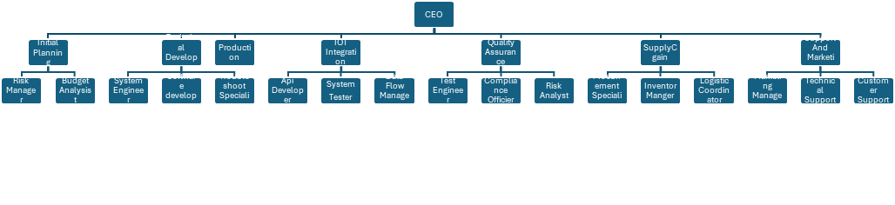

**Staffing Plan for Key Positions**

|  |  |  |  |  |  |
| --- | --- | --- | --- | --- | --- |
| Positions | Director in Charge | Required Timeline (Months) | Number of Staff | Roles & Responsibility of Staff | Recruitment Strategy |
| Planning Director | Mohammed Noor Alabbasi |  | **2** | Risk Manager (1), Budget Analyst (1) | Professional networks, job boards |
| Technical Development Director | Arsalan Habib |  | **6** | Systems Engineer (1), Software Developer (3), Troubleshooting Specialist (1) | Professional networks, job boards |
| Production Director | Emila Lopez |  | **3** | Shift Supervisor (1), Resource Planner (1), Production Analyst (1) | Professional networks, job boards |
| IoT Integration Director | Victoria Velasquez |  | **4** | API Developer (2), System Tester (1), Data Flow Manager (1) | University partnerships, technical job fairs |
| Quality Assurance Director | Dhana Gandham |  | **4** | Test Engineer (2), Compliance Officer (1), Risk Analyst (1) | University partnerships, technical job fairs |
| Supply Chain Director | Loic Wega |  | **4** | Procurement Specialist (2), Inventory Manager (1), Logistics Coordinator (1) | |  | | --- | | Industry-specific platforms, vendor referrals |  |  | | --- | |  | |
| Support&Marketing | Arun Chandana |  | **7** | Marketing Manager (1), Social Media Specialist (2), Technical Support (2), Customer Support (2) | |  | | --- | | Job Fairs,  Social Media |  |  | | --- | |  | |

**Purpose of staff Planning**

**Timeline and Strategies for Staffing**

**Phase 1: Preparation (Month 1)**

1.Finalize job descriptions and required qualifications for all roles.

2.Begin recruitment for the Project Manager and Systems Engineer roles as they are critical for initiating project activities.

**Strategy:** Utilize professional networks, job boards, and specialized recruitment agencies.

**Phase 2: Core Team Recruitment (Months 2-3)**

1. Hire Software Developers, Data Engineers, and the IoT Network Architect to begin development and integration tasks.

**Strategy:** Host hiring events and leverage partnerships with universities and tech hubs for accessing skilled candidates.

**Phase 3: Quality and Testing Team (Months 4-6)**

1.Recruit the Quality Manager to establish quality management processes early.

2.Bring in the Field-Testing Engineer to prepare for testing phases in subsequent months.

**Strategy:** Prioritize candidates with proven experience in quality assurance and field testing.

**Recruitment Strategies for Each Position**

**Qualifications for Each Position**

**Salary Range for Each Position**

**Conclusion and Next Steps**